AWS Cloud Lab

Creating an amazon vpc

Marcello Novak | CCNP

***Purpose***

This lab was our first lab dealing with the AWS console, and our task was to create an amazon virtual private cloud. By doing so, we would learn how to create public and private subnets, a gateway to the internet, and the VPC itself. A BPC allows the user to create a public web application, while going backstage to maintain the servers themselves.

***Screenshots***

Here’s the configuration for the VPC I created, sorry for the quality loss.

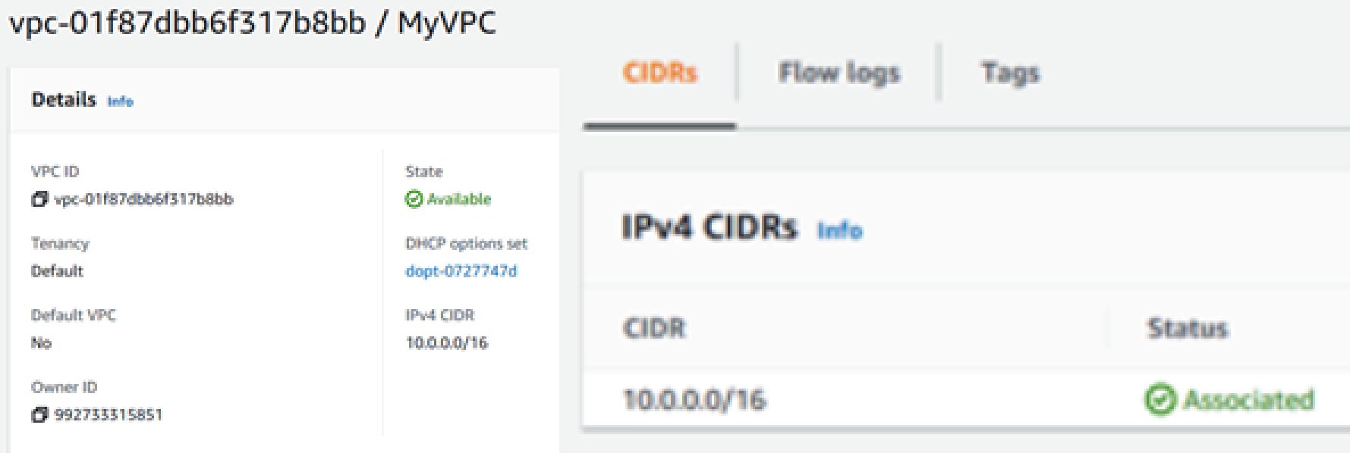

As you can see, the VPC has its own name and IPv4 gateway.



These are the subnets within the VPC itself.



And this is the internet gateway, that allows for public access.

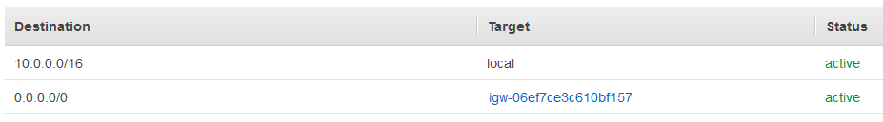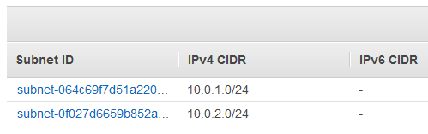

Finally, these are the routing table and routing associations for the VPC.

***Problems***

I really had no problems whatsoever with this lab. An engineer’s dream is for something to just work on the first try, and I never expected it to become reality. Overall, the lab is very smoothly constructed, so it wasn’t hard to follow.